**Victoria Trade License Check**

**Introduction**

The licensing body for Victoria is VBA (Victoria Building Authority), VBA is governed by Victorian government and manages the Victoria’s building and plumbing industries. [VBA Link: [https://www.vba.vic.gov.au/]](https://www.vba.vic.gov.au/)

As we know, the VBA portal got captcha so it is not possible to web scrape. Consequently, we are using an alternate website which gives the identical and reliable results of license status as compared to the VBA ones. [Alternate website (Licensed Trades) Link: <https://www.licensedtrades.com.au/>]

**Objective:** To verify the license status of Victorian trade professionals dynamically.

**Data Collection**

We used [Licensedtrades.com.au](https://www.licensedtrades.com.au/) to retrieve the data of Victorian trade professionals using an automated Web Scraping technique.

**Technology Used:**

* **Selenium**
* **Beautiful Soup**
* **Jupyter Notebook**
* **Python3**

**Licensed Trades (Alternate website)**

[Licensedtrades.com.au](https://www.licensedtrades.com.au/) contains Australian Trade Professionals data for more than 1,600,000 licenses; indexing over 58 licensing bodies.

Particularly, for Victoria it got 10 licensing bodies as following:

* VIC Surveyors Board
* Health.VIC
* VIC Plumbing Industry Commission
* VIC Labour hire authority
* ARBV - Architects Registration Board of Victoria
* VBA
* VIC Energysafe
* WorkSafe VIC
* VIC Pest Control Licence Holders
* Victoria Police

However, among all these 10 licensing bodies we are interested in only two i.e., ***VBA*** and ***VIC Plumbing Industry Commission***.

**Data Description**

As we are Web Scraping [Licensedtrades.com.au](https://www.licensedtrades.com.au/) website, which gives us an output as following.

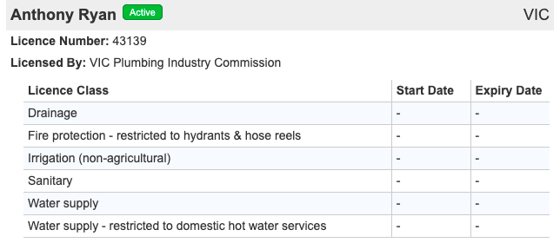

From above output, we are fetching 7 columns i.e. **Business** **Name**, **License Status**, **Address**, **Licensed By**, **License Class**, **Start date**, & **Expiry date. Furthermore, we are creating a table as our ultimate dataset.**

**Coverage of License Categories**

[Licensedtrades.com.au](https://www.licensedtrades.com.au/) accommodates the Trade professional License details for 42 categories as following:

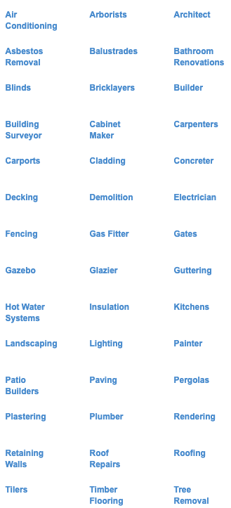

Among these 42 categories we are analyzing only Builder, Building Surveyor, Gas Fitter, and Plumber in depth.

* **Builder**

In Victoria, the Building Practitioners Board (BPB) regulates the building industry.

There are three types of BPB registration certificates in Victoria:

1. Domestic Builder – Unlimited (DB-U)
2. Domestic Builder – Limited (DB-L)
3. Domestic Builder – Manager (DB-M)

Trade professionals in the **DB-U** class are registered to carry out all phases of domestic work or supervise, manage or appoint subcontractors.

A **DB-M** Certificate of Registration allows the registered building professional to arrange for DB-U or DB-L practitioners to carry out building work or manage their activities.

A Domestic Builder – Limited (**DB-L**) registration certificates are authorised to carry out one only of a variety of building works, including, but not limited to:

* Bathroom, kitchen and laundry renovations
* Brickwork
* Cabinet making and joinery
* Carpentry
* Fence and gate construction
* Floors, slabs, and footings
* Sub-floor works
* Restumpers and reblockers

Typically, a Certificate of Registration must be renewed every three years.

* **Building Surveyor**

The Victorian Building Authority states that a building surveyor is “generally responsible for ensuring that the building work complies with the requirements of the Building Act 1993 and the Building Regulations 2006.” In Victoria, the VBA requires surveyors to become registered building practitioners.

* **Gas Fitter**

In Victoria, gas fitters are licensed by the Plumbing Industry Council (PIC), which operates under the umbrella of the Victorian Building Authority (VBA).

There are two types of gas fitting licences in Victoria:

* 1. A Class A licence authorises a gas fitter to install light commercial and domestic appliances such as cookers, heaters (space heaters or central heaters), and other appliances that are classified as Type A gas appliances.
  2. A Class B licence authorises a gas fitter to work on Type B gas installations that consume gas in excess of 10MJ (mega joules) per hour.
* **Plumber**

Plumbing work in Victoria is regulated by the Plumbing Industry Council (PIC) which is under the auspices of the Victorian Building Authority (VBA).

Plumbers in Victoria are licensed in eight classes: Water Supply, Gasfitting, Sanitary, Roofing (Stormwater), Drainage, Mechanical Services, Fire Protection or Irrigation (Non-agricultural).

**Advantages**

* Holds a massive and reliable trade licensing information of 42 categories and 58 licensing bodies.
* The VBA validates the licence of a **Building Practitioner and** a **Plumber** only, however the[Licensedtrades.com.au](https://www.licensedtrades.com.au/) verifies a wider range of license categories.
* The website gets updated weekly or daily.

**Disadvantages**

* Expiry and Start date for some of the licenses are missing or not updated (the old expiry date is present), though the license status is correct. Hence, the License status is prior to the expiry date.

**Testing**

This testing comprises the comparison between license details obtained from VBA (Victoria Building Authority) and [Licensedtrades.com.au](https://www.licensedtrades.com.au/) websites.

* **Inputs for Testing**

**Inputs for VBA**:

* Practitioner Name
* Registration Number

**Inputs for** [**Licensedtrades.com.au**](https://www.licensedtrades.com.au/):

* Licence Number
* Licensee or Business Name

So, our input would be a list of License numbers.

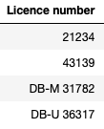

* **Output of Testing**

1. **License number:** 21234

**VBA Output**

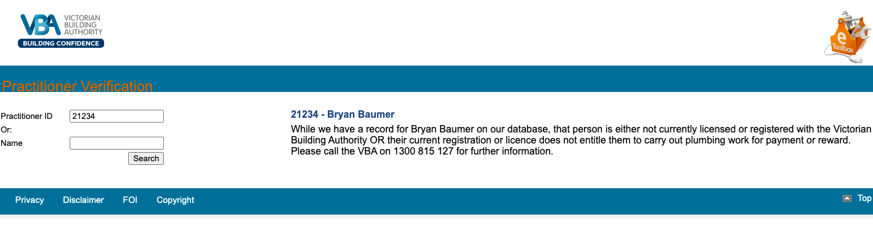

**[Licensedtrades.com.au](https://www.licensedtrades.com.au/" \o "Licensedtrades.com.au) Output**

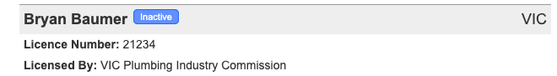

1. **License number:** 43139

**VBA Output**

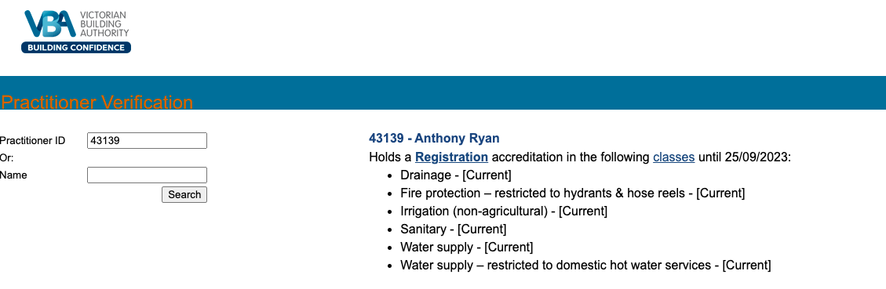

[**Licensedtrades.com.au**](https://www.licensedtrades.com.au/) **Output**

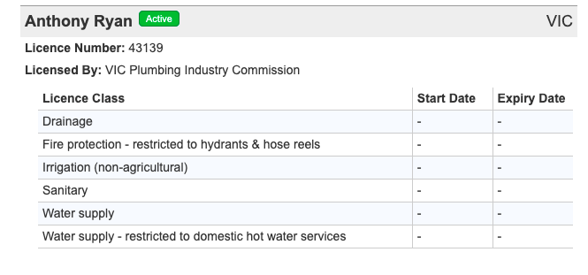

1. **License number:** DB-M 31782

**VBA Output**

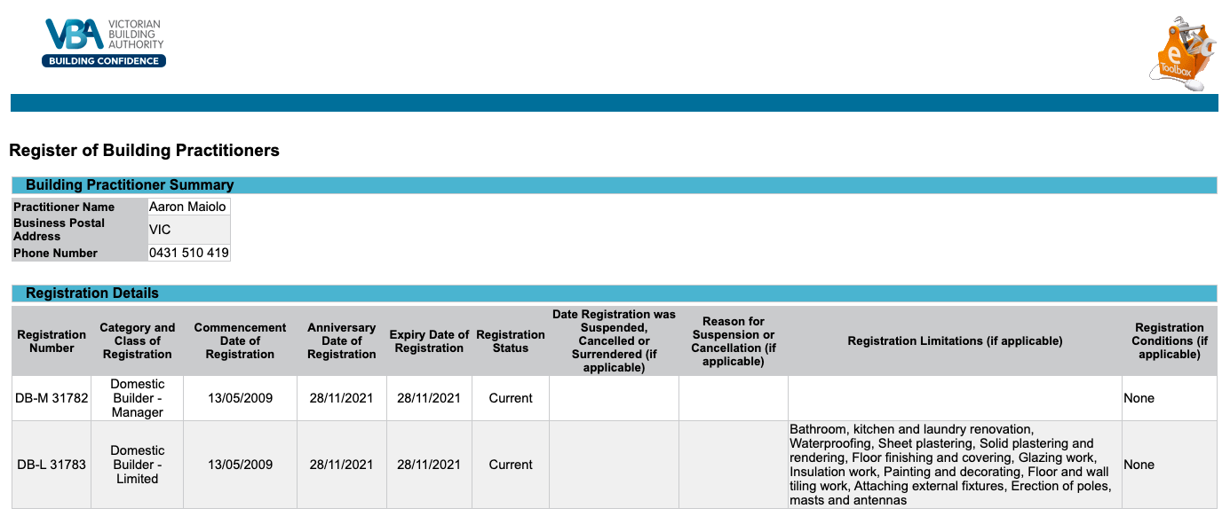

[**Licensedtrades.com.au**](https://www.licensedtrades.com.au/) **Output**

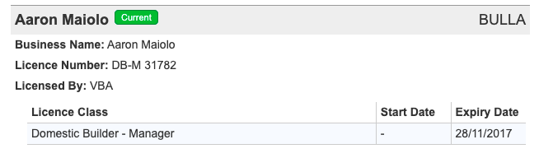

1. **License number:** DB-U 36317

**VBA Output**

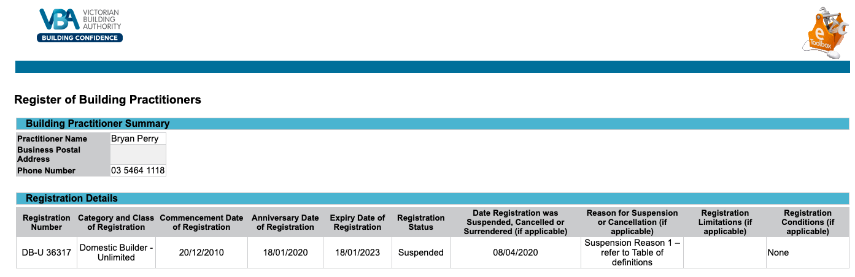

[**Licensedtrades.com.au**](https://www.licensedtrades.com.au/) **Output**

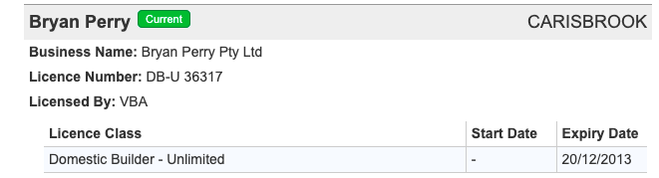

From the above outputs, we figured out that the licensing details obtained from both VBA & [Licensedtrades.com.au](https://www.licensedtrades.com.au/) are identical, besides [Licensedtrades.com.au](https://www.licensedtrades.com.au/) have not updated the expiry date of licenses. Consequently, we can undoubtedly be confident about the results though we have to neglect the expiry date.

**Web Scraping Process**

* **Input**

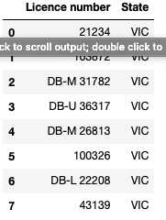

* **Output**

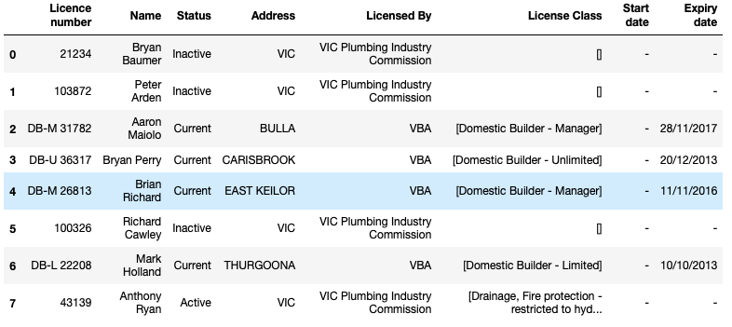

**Conclusion**

[Licensedtrades.com.au](https://www.licensedtrades.com.au/) is a robust source of extracting trade professionals licensing details due to possessing data of 58 licensing bodies and 42 trade categories; it gets updated daily or weekly. In addition, [Licensedtrades.com.au](https://www.licensedtrades.com.au/) can validate several licensing bodies, on the other hand, official VBA website allows the general public to validate only the licence of a **Building Practitioner and** a **Plumber**.

Ultimately, we can surely trust the **license status** obtained from [Licensedtrades.com.au](https://www.licensedtrades.com.au/) and ignore the outdated expiry date.